**KPI Route Map: Highlights route performance based on a given KPI over the map**

Our unique custom Power BI visual saves time and effort of analyzing route performance for a flight, cruise etc. based on a given KPI like fuel cost, number of visitors, revenue etc.

**Business Case:**

Operations teams for any airline rely on reports for tracking the performance of various flight route and focus on analyzing the best/worst utilized flights for all major carriers. Same holds equally true for shipping and cruise. A classical problem that is always faced by logistics operators as well, is mapping a route for better supply chain planning. This again requires the route performance data.

Major decisions are taken based on reporting of this data (mostly over the map) highlighting route health as shown below. So, support teams spend hours manually checking various reports and charts, to identify route performance and then highlight them manually in the maps. Based on which corrective steps are taken by authorities.

There are several route map visuals available in market which help to showcase the transport or journey routes of flight or ship on map and are used in reports to give at a glance image of entire routes but for categorizing them as best, average or poor performer, separate data table or matrix is needed to be available in conjunction with the map (see image below). In short, there is the unavailability of a route map which takes KPI data directly in it and highlights the route accordingly.

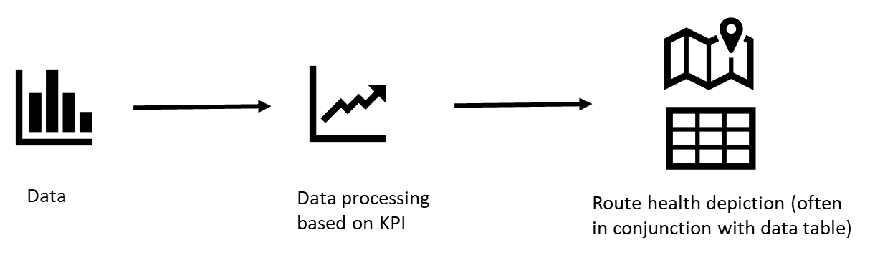

A sample Power BI route map displaying data in conjunction with table and no KPI based route highlight over map. Data table may show their health separately on selection. [Source](https://www.youtube.com/watch?v=o5Fc1ujta0w)

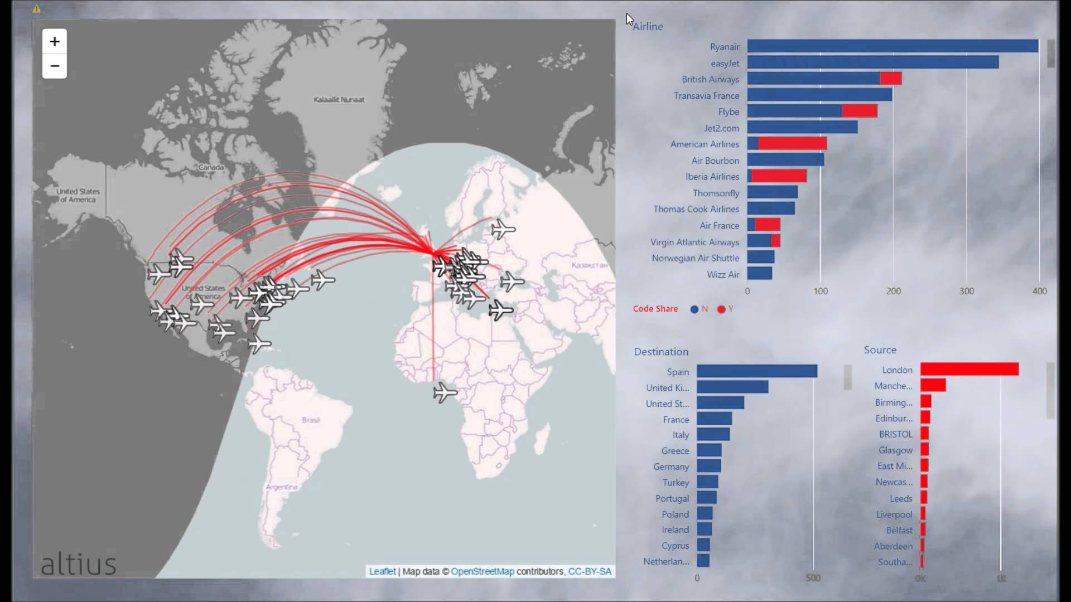

We created Power BI based custom visual which takes the KPI data directly in visual itself and automatically highlights the route based on their KPI performance. Hence, there is no need to have additional data table along with the map to calculate or decide the route health. It also takes away the overhead of repeated process of manually updating the map. So, time and effort get saved and decisions based on route performance can be taken in less time.

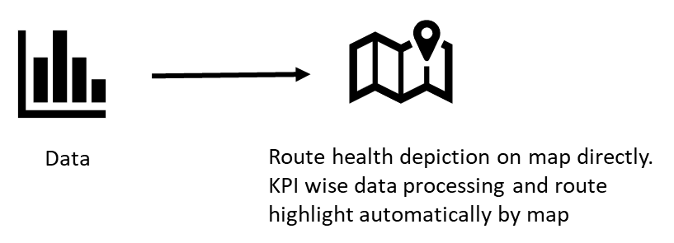

Our Power BI route map displaying routes with different gradients based on KPI data directly fetched to the visual. No separate data table is required to highlight the route health. It also displays required data in tooltip for any route and hence no separate table is required to complement the map for data retrieval. It also separates out domestic and international routes.

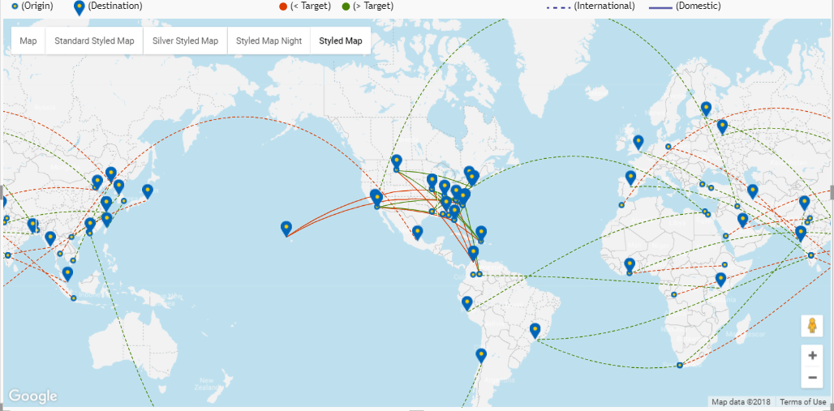

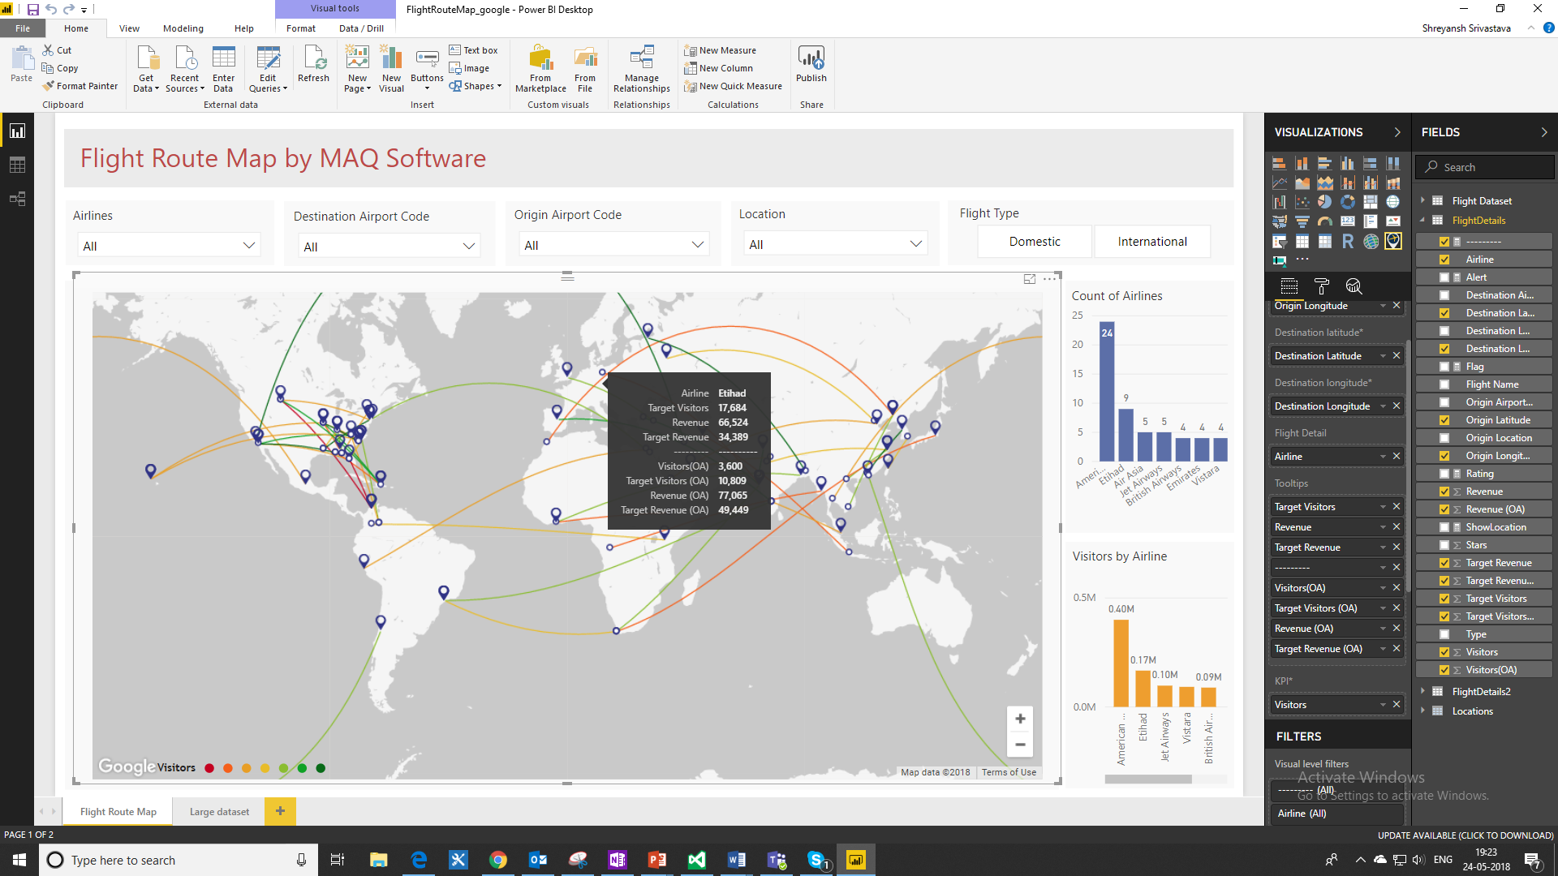****

**Scenario:**

**Expedia**, the global travel technology, and aggregator company were looking for a Power BI based visual which independently and at a glance can provide Airline route analysis by providing following features inside the visual itself:

* Route highlight (with gradients ranging from red to green) based on KPI data for performance comparison
* Domestic vs International route highlight
* Provide the comparison of an airline KPI data with other airlines data
* Ability to view route specific data
* Specific location-based route data highlight

This will enable Expedia to let their partners and customers know, to focus on which specific route for a given KPI. And based on the same customers can also maneuver their plan. Real-time reporting of the route performance can help management take an informed decision at right time for the right set of routes. This can save a lot of costs. Not only this but when booking business travel, there’s more to consider than just the cost of flights. Customer service, on-time performance, and airport locations should also be a part of every business traveler’s decision. And Expedia needed one such way to project this data so that travelers can have full awareness by flight performance based on various parameters of their choice.

People often make travel decisions based on a limited number of variables, but for Expedia, nothing is more important than getting people to their destinations on time and without significant delays. And aligned with that thought process, this KPI route map has been designed.

**Key Challenges:**

* Creating Power BI based route map visual intuitive enough for taking KPI data as input
* The visual should generate multiple ranges based on KPI data and assign a color to the routes accordingly
* Provision to compare the data of one airline with other airline data
* Route and location-specific data can also be generated if required
* Visual should be interactive with other charts
* The map should be clean and best in class, aesthetic wise

**Solution:**

We created Power BI custom visual which can render Map API from the best in class map providers like Google, Bing or OpenStreet by just changing configurations in the visual setting. Based on the requirement and cost involved, any of the mentioned map flavors can be chosen. Visual is made feature rich with the requirements as requested by Expedia. This visual takes KPI value directly in its data model and ranges of KPI along with their respective color can be set. Though visuals by default intuitively assign color gradient to each KPI range, from red to green, depicting lower to the higher range of KPI value. The same colors get allocated to routes over the map in a clean and precise way which shows the performance of route for that KPI.

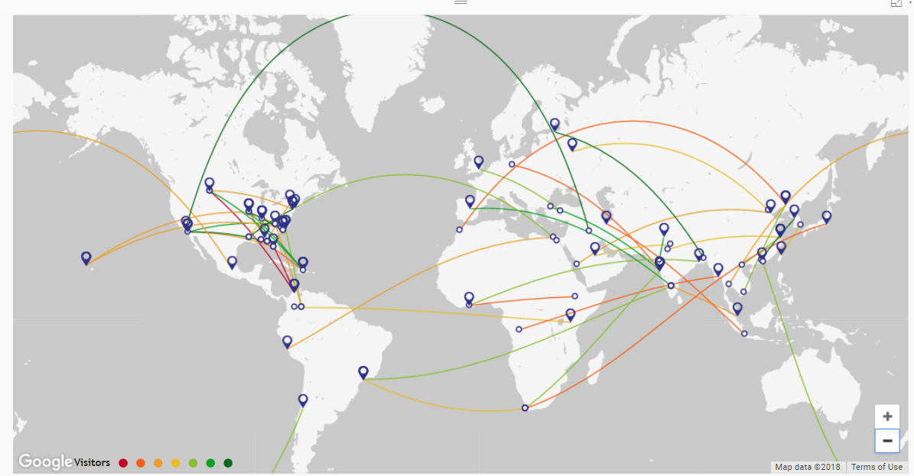

\

**Key Highlights:**

* KPI value-based map route highlight with 7 colour gradients
* Individual route highlight on-hover of route and data slice on click of it
* Route filter on-click of location (origin/destination)
* Tooltip with the ability to showcase multiple KPI datapoints
* Availability of 5 map variations
* Tooltip enabled route and ‘Origin’, ‘Destination’ icons
* Configurable path colour and path display setting (solid/dash)
* Animated path visualization for simulating flight/ship track
* Customized map with cleaner version without city names and boundary lines
* Pan scan, zoom-in, zoom-out etc. to get the better imagery of map routes

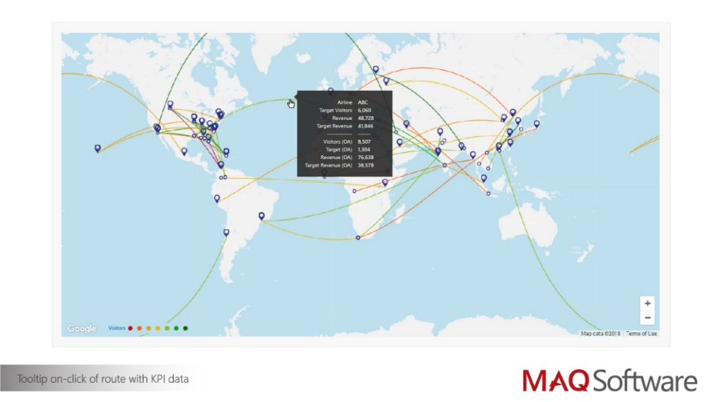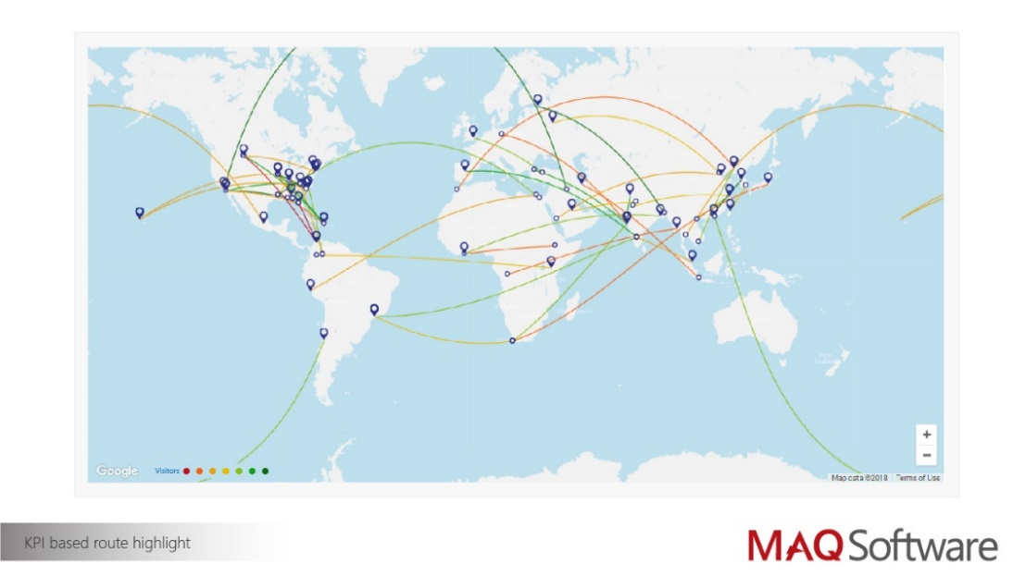

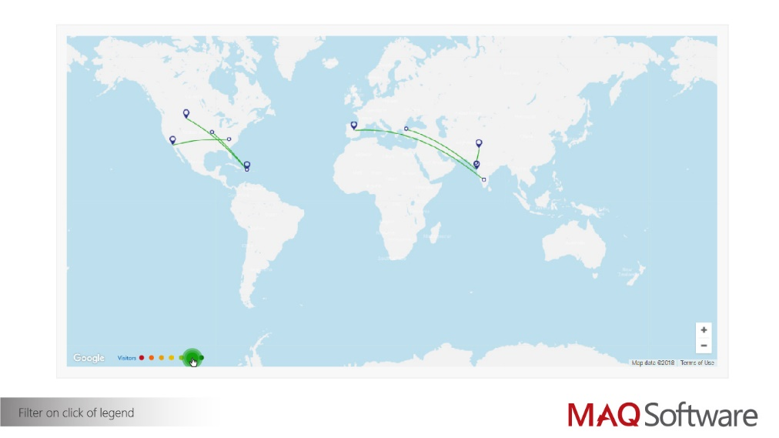

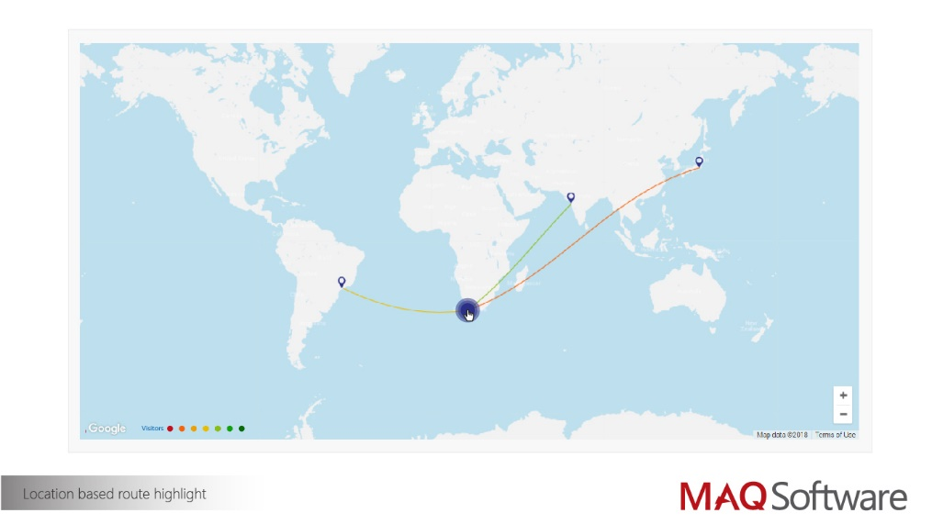

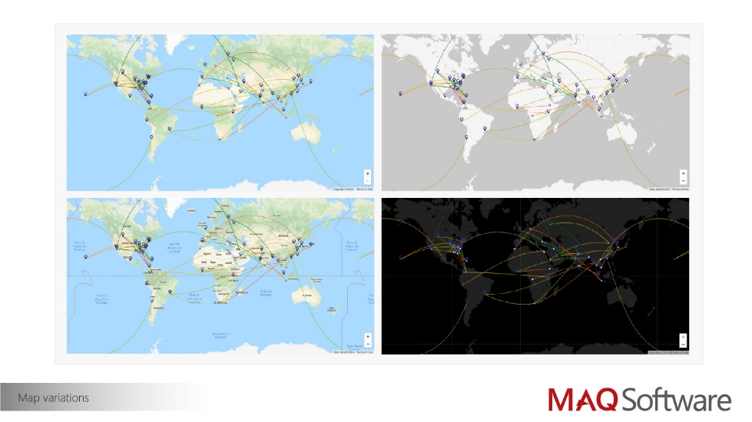

Setup of the KPI route map requires the user to just download the visual in their Power BI solution and provide appropriate data to it. Next, one can provide visual settings as per their requirement to choose appropriate KPI data, set ranges for KPI, assign a color to it, set solid and dashed lines etc. More details on setting can be found out in user guide [here](https://github.com/maqsoftware/PowerBI-visuals/blob/master/documents/Published/KPI%20Route%20Map/KPI%20based%20route%20map%20-%20User%20Guide.docx?raw=true). Below is a quick setting synopsis using snapshots.

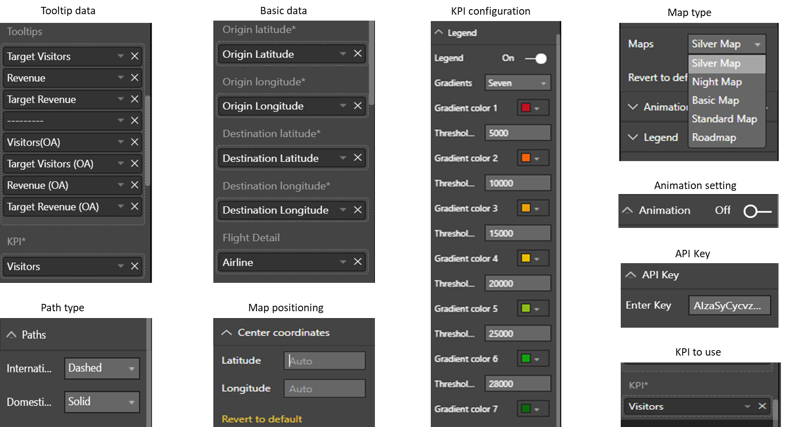

**Figure: KPI Map settings and configurations**

So unlike other available route maps, this is an advanced route map, which not only provides the route between multiple locations, but also provides the facility to highlight routes based on certain KPIs which can be used for performance comparison.

**Business Outcome:**

Our Power BI custom visual KPI route map gives a ‘one stop solution’ for reporting route performance based on KPI. Not only it provides route over the map being used by the flight, ship or cruise but also highlights their performance along with relevant data on the map itself while interacting with them. Also, if connected with live data, real-time reporting can be achieved. Overall, it will save real estate of the report, time to develop it and reduce the effort of creating separate other tables for reporting. Basically, it reduces the entire turnaround time of reporting. Leveraging this benefit, Operations teams or travelers can now take major decisions at early stage saving them a lot of their cost.

**Outcome Highlights:**

* Help reduce costs and complexity.
* Improve real-time accuracy and customer service
* Help improve productivity through effective reporting